PRACTICAL No. 3
Scanning networks, Enumeration and sniffing:
Using the software tools/commands to perform the following, generate an analysis report:
A. Port scanning
B. Network scanning
C. IDS
D. Network Sniffing

- Port Scanning:

Nmap Tool: Nmap is a free, open source and multi-platform network security scanner used for network discovery and security auditing. Nmap can be extremely useful for helping you get to the root of the problem you are investigating, verify firewall rules or validate your routing tables are configured correctly.

Link to download nmap-7.92 for windows platform:
https://nmap.org/download.html

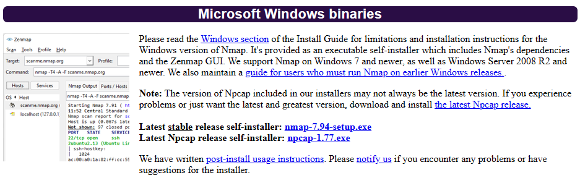
Nmap needs Npcap which is the Nmap Project's packet capture (and sending) library for Microsoft Windows.
Link to download Npcap 0.9984 for windows platform:
https://nmap.org/npcap/dist/
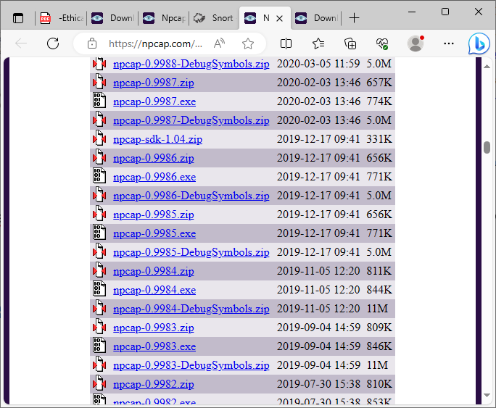

Note: We can use more command to display one screen of output at a time. Here use /E option and pass the other command output to more command using | (pipe) symbol.
Example: C:> dir | more/E

Questions:
- Display the following for ip address 127.0.0.1 or any other ip address

- Scan open ports (syntax: nmap –open ip_address / url )

Output:
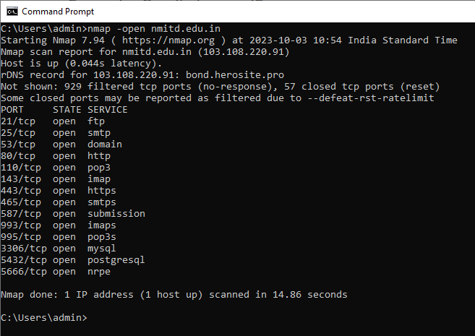

- Scan ports (syntax: nmap ip_address / url )

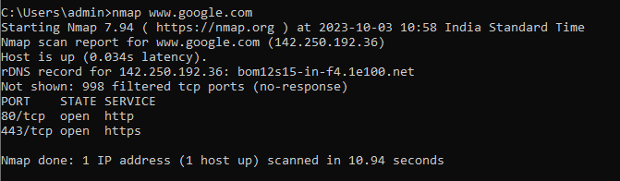

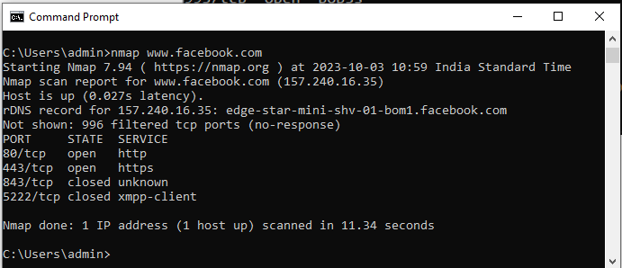

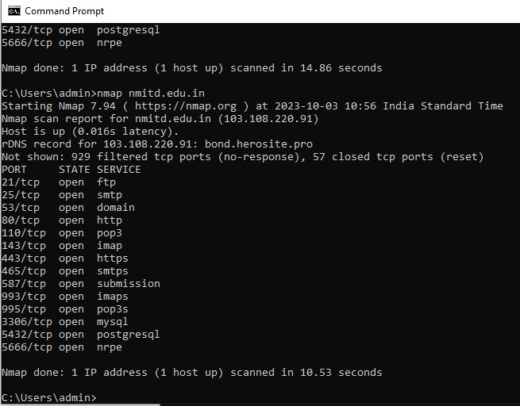

c. Scan single port (syntax: nmap -p 80 ip_address)

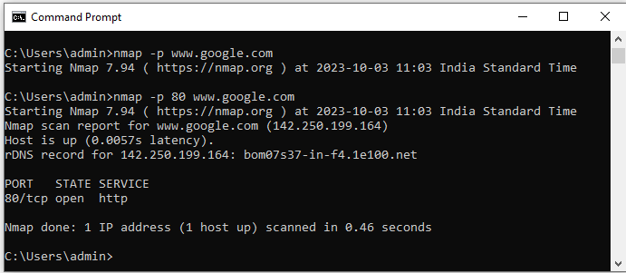

- Scan specified range of ports (syntax: nmap -p 1-200 ip_address)
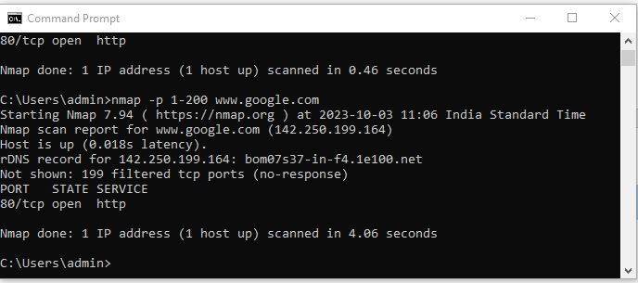

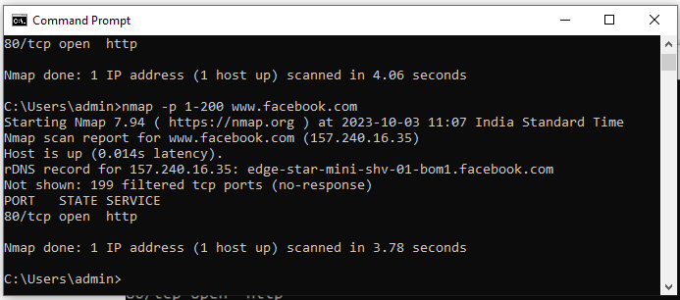

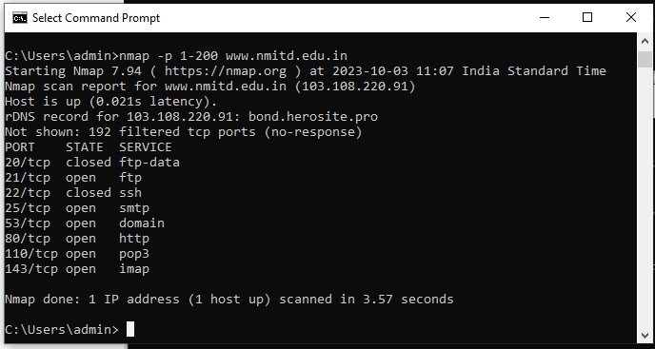

  - Scan entire port range (syntax: nmap -p 1-65535 ip_address)

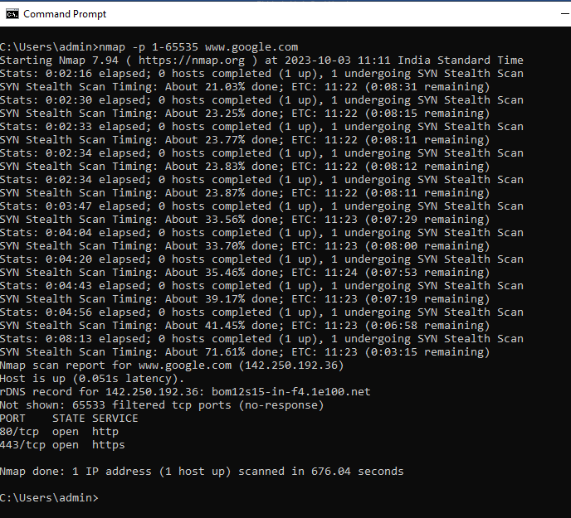

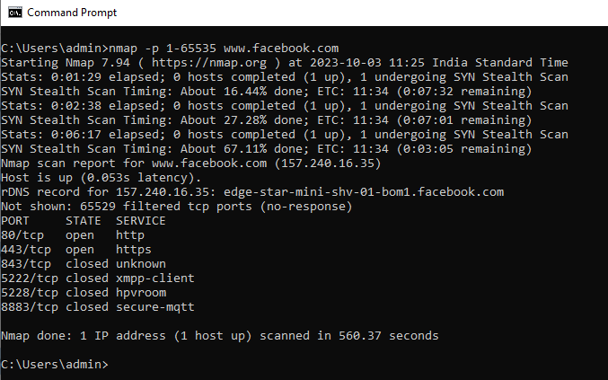

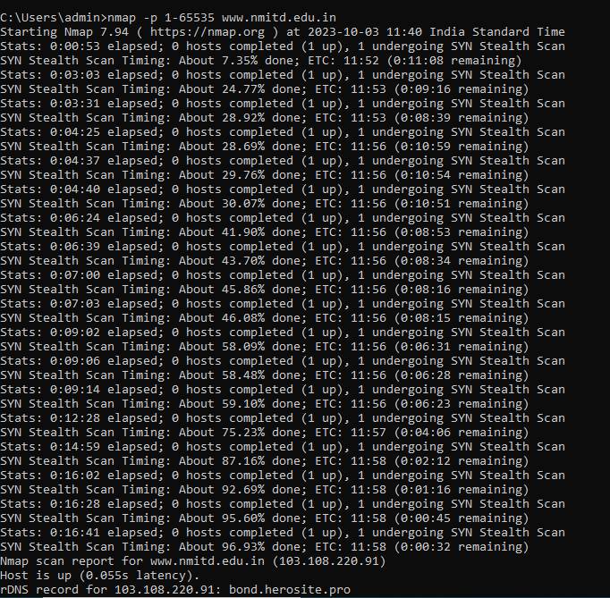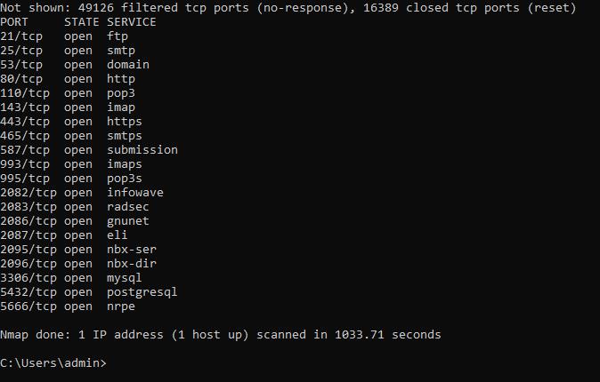

- Scan top 100 ports (fast scan) (syntax: nmap -F ip_address )

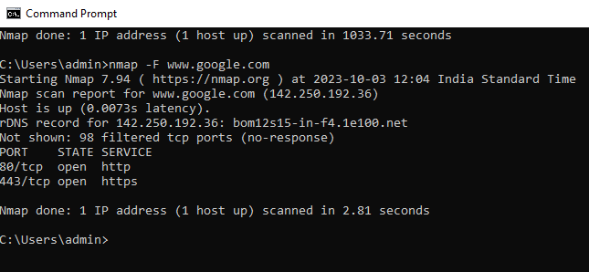

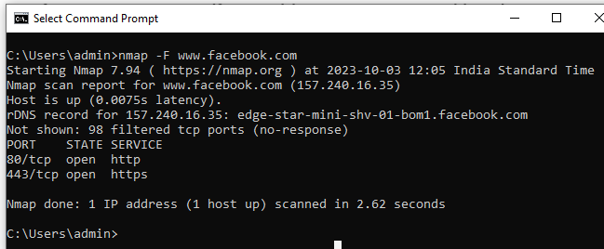

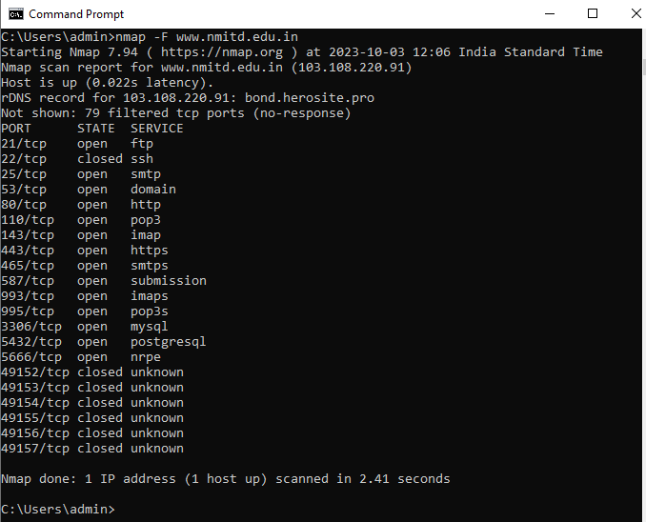
References
- https://www.youtube.com/watch?v=MoGxY3yCySk
- Video basics of networking https://youtu.be/oiYrsR5oJSE

- Network scanning:
Nmap Tool:
Nmap is also used to scan networks. Nmap is now one of the core tools used by network administrators to map their networks. The program can be used to find live hosts on a network, perform port scanning, ping sweeps, OS detection, and version detection.

Q. Demonstrate how to scan networks. Explain the steps and attach output.

Nmap <ipconfig>

- Ping Scan – It returns a list of hosts on your network and the total number of assigned IP addresses. If you spot any hosts or IP addresses on this list that you cannot account for, you can then run further commands to investigate them further.

Syntax: nmap –sP <ip address>

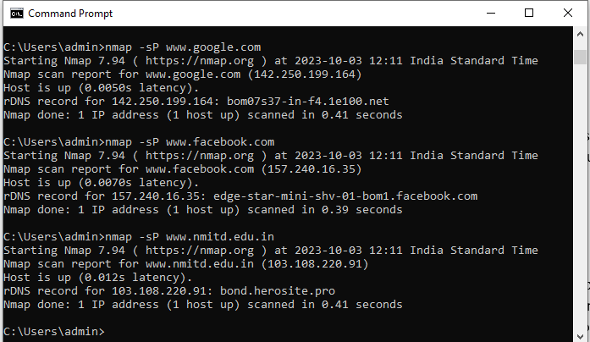

- Host Scan – Unlike a ping scan, a host scan actively sends ARP request packets to all the hosts connected to your network. Each host then responds to this packet with another ARP packet containing its status and MAC address. This can be a powerful way of spotting suspicious hosts connected to your network.

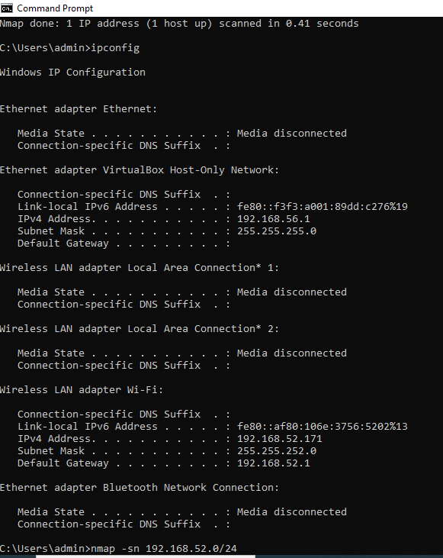

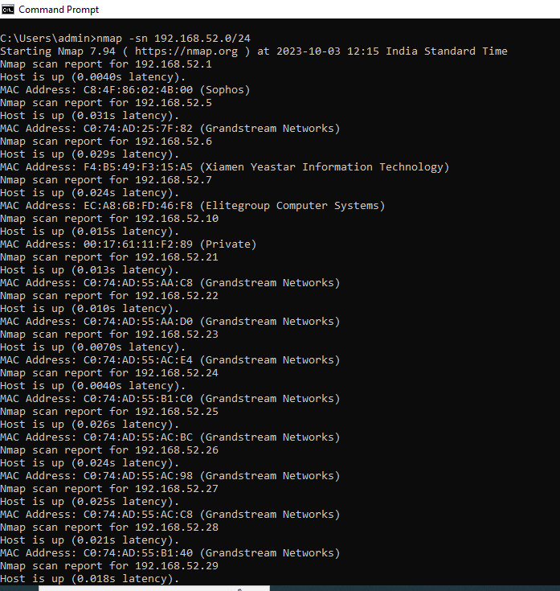

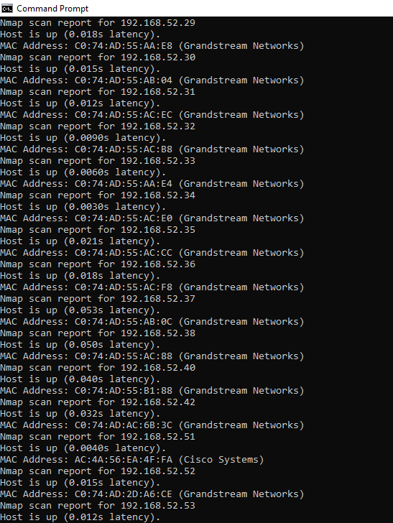
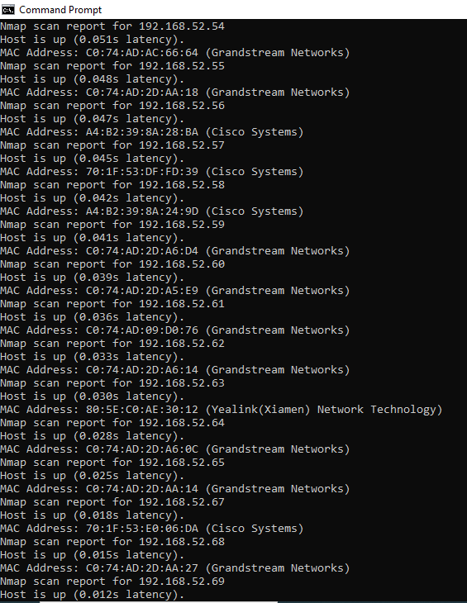
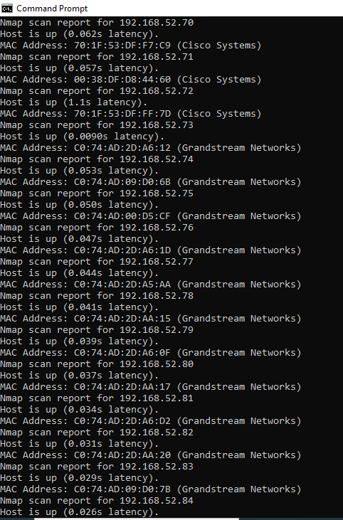
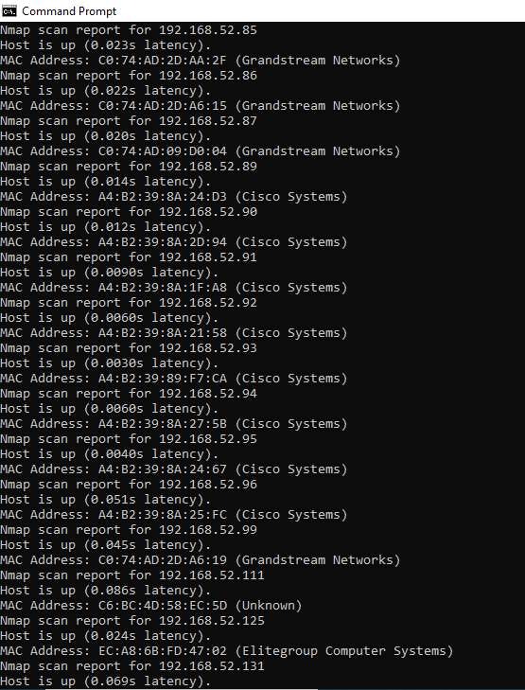
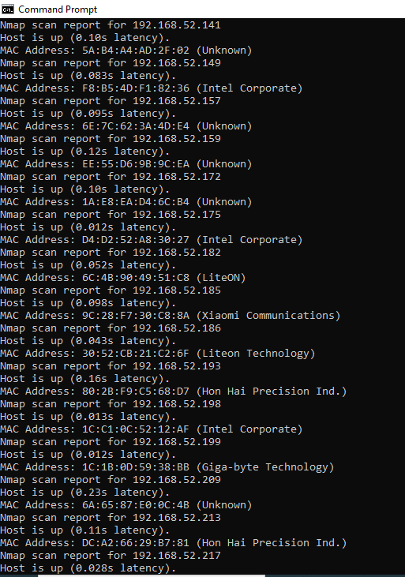
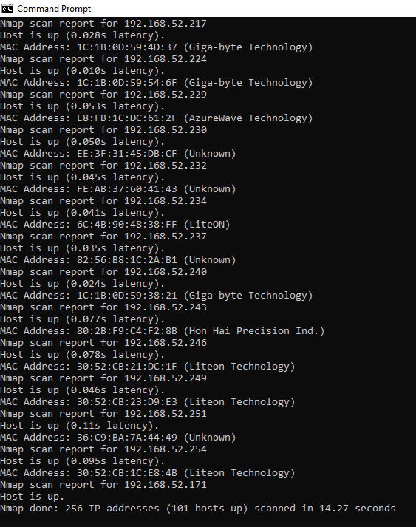

- If you see anything unusual in this list, you can then run a DNS query on a specific host, by using:

Syntax: namp –sL <ip address>

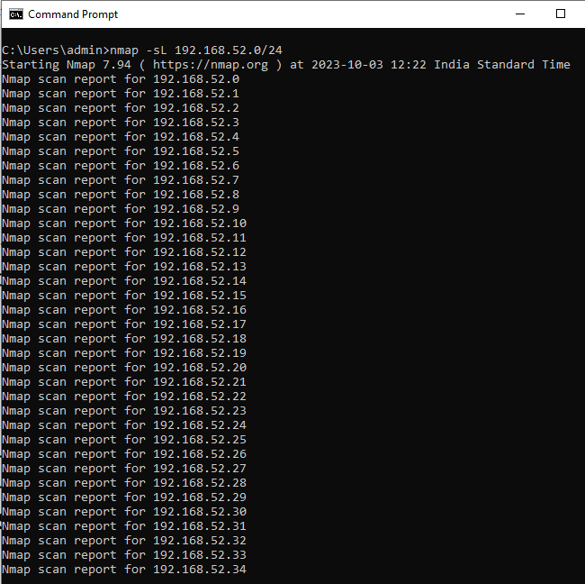
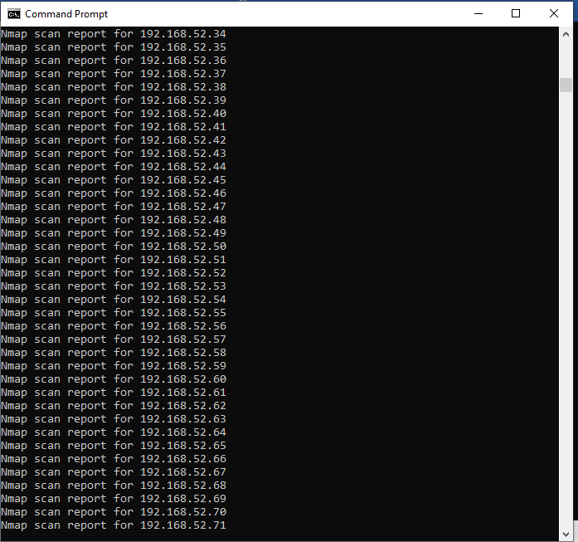
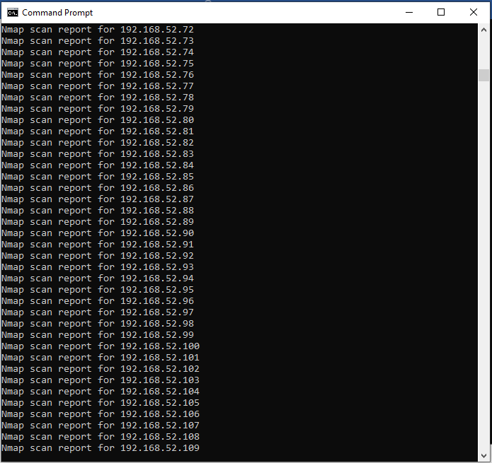
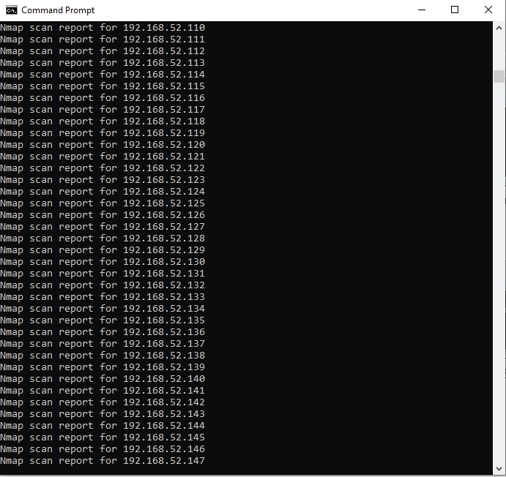
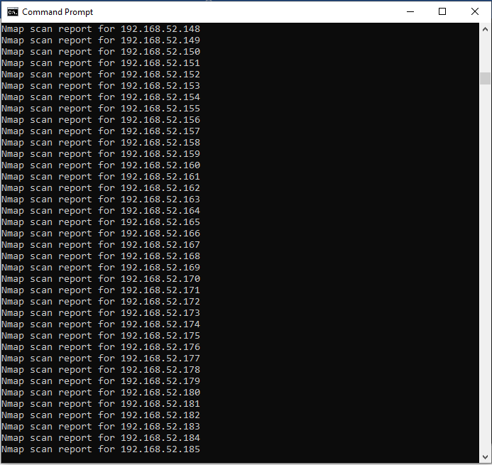
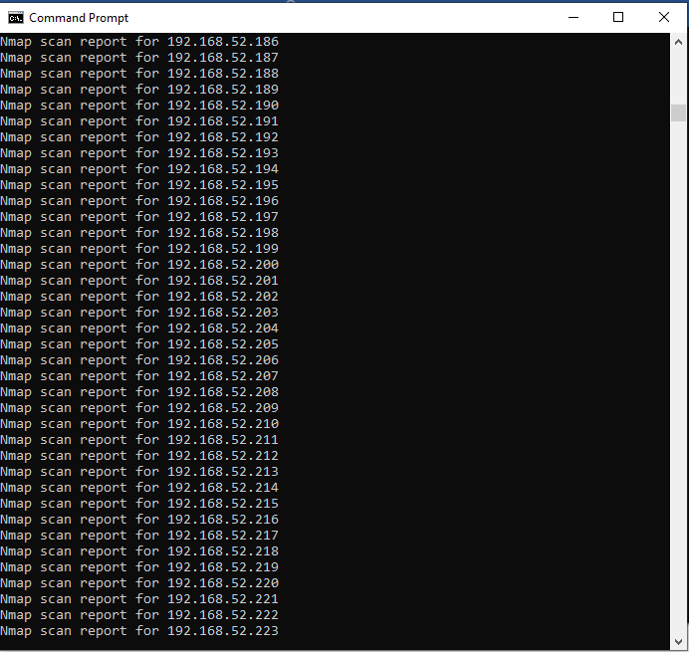
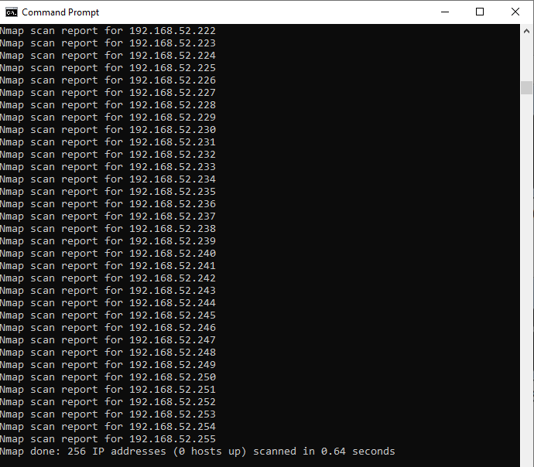

This returns a list of names associated with the scanned IP. This description provides information on what the IP is actually for.
- OS Scan – This command return information on the OS (and version) of a host.

Syntax: nmap –O <target IP>

Note: you can find the OS of your neighboring PC by entering the IP addr as target IP addr

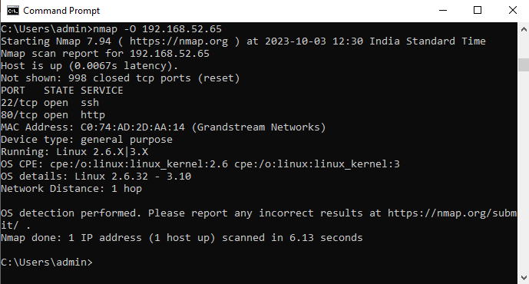

References:
- https://www.varonis.com/blog/nmap-commands/
- https://www.youtube.com/watch?v=IoIsTrKrl-0

